Initial Design Concept

# Section A: Game Design

The team have been tasked with designing and creating a resource management game with the aim of monitoring and investigating how territorial ownership affects human behaviour.

We have proposed to make the game in a 2d space setting, with players starting off on a “home world” with a number of colonist ships or even a single ships which is still being decided upon. The players will use the ships to travel and colonise planets in the generated universe, each planet will produce a different amounts of different resources.

Players will start in a corner of the map and gradually move out from their home planet colonising planets as their ships fan out occupying planets as they go. Only when a ship is on a planet will it collect the resources there eventually moving on to the next when the resources are used up.

The team proposed a variation of units which will have different characteristics such as colony ships and soldier ships.

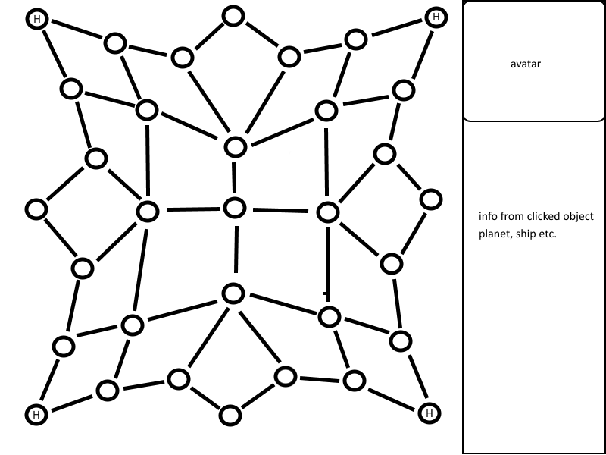

Figure : Example of Game Map

Above is a mock-up of the in-game map. Each node is a separate planet and the H is a possible home planet. The maps could be sized up or sized down depending on players or preference.

The proposal is to use 3 different resources like minerals, fuel and anti-matter. The rarity and amount of said resource would be up to the experiment runner to set within the customizable maps, however each map would have a standard set up with anti-matter being rarer than the others.

If 2 player’s ships meet on a planet then a dialog between them will be produced e.g. Talk, attack or run. Depending on players actions a number of different scenarios can occur for example:

If both players talk then they can exchange set dialog options allowing them to express their intent.

If both players attack then they will each take damage.

If both players flee then they will each leave the planet.

If one player talks and the other attacks the player who talked will take damage.

If one player attacks and the other flees then the attack will miss and the fleeing player will leave the planet with the other player occupying it.

If one player talks and the other flees then the talking player will remain to occupy the planet.

Discussions of a trading option could also be implemented so that players can trade with each other, trading unneeded resources for ones they do need.

For a player to win they must either destroy all other players ships or reach a threshold value of resources to be able to build an “FTL (faster than light) drive” first. As the game progresses the resources will become more and more contested as players will have spread out and going for the rarer or more abundant planets, meaning later in the game player interaction will be more common as the players have spread out making it harder to gather the resources you want.

As put across in the brief and meeting, there are 2 different versions of multiplayer intended. On one hand is a one on one type gameplay where it is player vs player or player vs ai and on the other is a version with multiple players and ai against each other, each with a separate home world and ships or possibly a version where only players have a home world and the ai are roaming ships who move around the universe randomly and interact with other ships randomly.

As a team we have decided on some customisation in not only each players look but in aspects of the game that effect the players behaviour, e.g. Changing the amount of resources a planet produces or the starting variables of the players like number of ships they start with. As such this would be made easier by having a set map for each scenario, meaning you could change everything in the maps rather easy as this would be done either in game when setting up a match, or could be done using a text file outside of the program that is associated with the given map. The same process could be used for editing a lot of other things as well such as the ships health or resource collection speed using a text file to be loaded when the game is started. If we go with a single ship version then the customisation could also be used to personalise the ship as well if multiple then perhaps only the colour.

The specification has a number of needs and functions that the program has to do and the team feel that the design is beginning to shape these needs. The need for territory and resource management is fulfilled by the planets and ships, as players will only be able to harvest from a set number of places meaning they will have to manage where they put their ships depending on what resources they need. The interaction between players, consequences and territorial invasion is fulfilled as that players can still interact with each other if they both have a ship on the same planet with different ships providing different benefits. The customisation options will be met by allowing players to customise their avatar before they start e.g. Look, gender or clothes but also allowing the person running and monitoring the experiment will be able to change the environments variables using a text file.

# Roles and tasks among group members

To ensure that the creation of our game runs as smoothly as possible we have dictated roles and specific tasks to each member. This section of the document will discuss the roles of each group member and the various tasks that they should be expected to complete.

Jack Hoyle – Lead Programmer/Designer  
Jack’s role within the team will be that of the lead programmer/designer. He will have a leader type role within the group helping people keep on track and make final decisions based on input and debate within the group.

Jack will also assist with the programming of the game itself, ensuring that any features that need to be implemented will be within the scheduled time plan.

Daniel Masterson – Programmer/Sound Engineer  
Daniels role within the team will also be that of a programmer and sound engineer for the game, he will be assisting with the writing of the game and also ensuring that features are implemented whilst following the time plan. Daniel will also have the job of creating the base engine of the game that we will be expanding on to ensure that we have a good base to work from.

Furthermore Daniel will also have the responsibility of creating or finding any sound assets that will be available within the game, to ensure that it is relevant and works well within the game.

Adam Kadow – Programmer/Artist  
Adam’s role within the team will be that of a programmer and artist. Like the previous two members of the group he will be writing the game itself and ensuring that all of the features are implemented on time and within the constraints of the time plan.

Furthermore Adam will be in charge of the various different art resources that will be available within the game, he will be in charge of finding relevant open source assets that can be used and also creating his own when needed.

Josh Gibson/Philip Devine – Producers/Project Managers/Testing  
Josh and Philips’ role within the team will be to handle to producing side of the project. It is essential for the project to be run smoothly that it is managed and it will be their job to ensure that the project is on track and also that each member of the group is made fully aware about things such as meeting time and locations, it will also be the job of these two members of the group to check the current progress of the task against the created time plan to assign tasks accordingly. When checking against the plan it is also important to update the plan to reflect any changes that may have occurred during that week. To continue to ensure that the project will stay on track.

It will also be up to these members of the team to produce and quality control any documentation that will be attached to the project. This will include the maintenance and completion of the design document, as well as any user documentation that will be produced. They will also be in charge of ensuring that all meetings are documented, including timesheets and minutes documents.

When the project is completed it will also need to be tested, as these two members of the group will not have had as much of as hands-on input when it comes to programming the game itself they will be the best candidates when it comes to testing the game as they complete tasks as a user rather than a developer. This will help to provide a more in-depth testing document and help minimise errors when the project is completed.

# Appendix

